Ideation Phase
Empathize & Discover

Date | 31 January 2025
Team ID | LTVIP2025TMID21153
Project Name | Freelance Finder
Maximum Marks | 4 Marks

Empathy Map Canvas:
Understand the needs, frustrations, and behaviors of freelance professionals seeking consistent work through a platform like Freelance Finder.

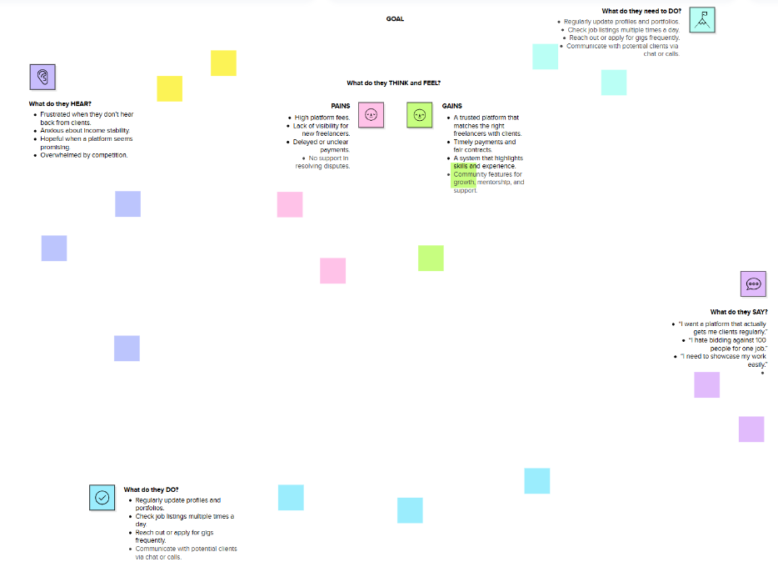

Reference: https://www.mural.co/templates/empathy-map-canvas

